Bug – Register account gives server error after selecting register button

Navigate to <https://ensekautomationcandidatetest.azurewebsites.net/Account/Register> and enter an email address and valid password in the password and confirm password input boxes.

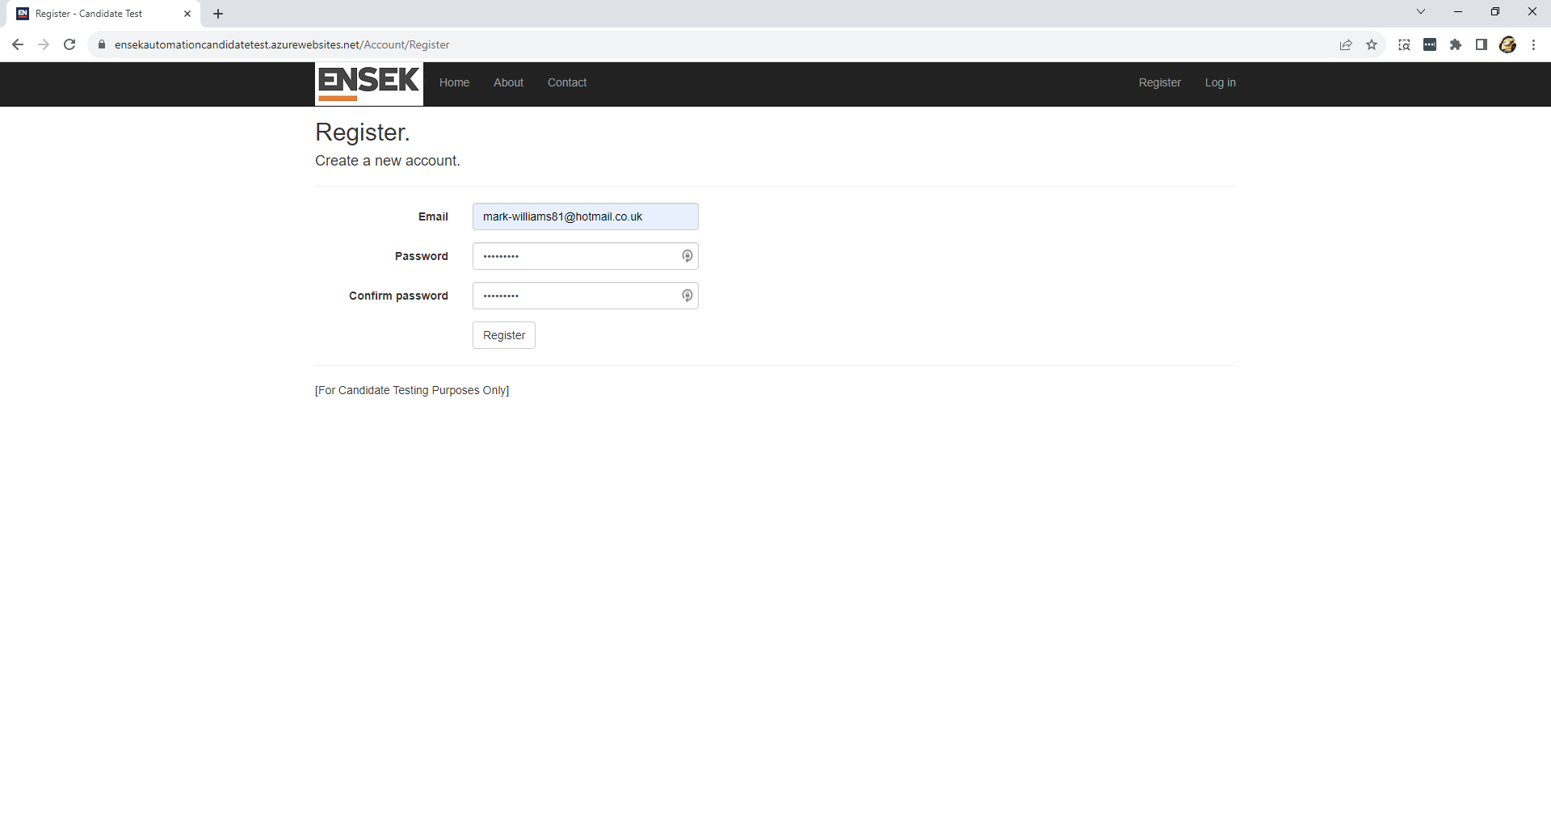

Select the register button.

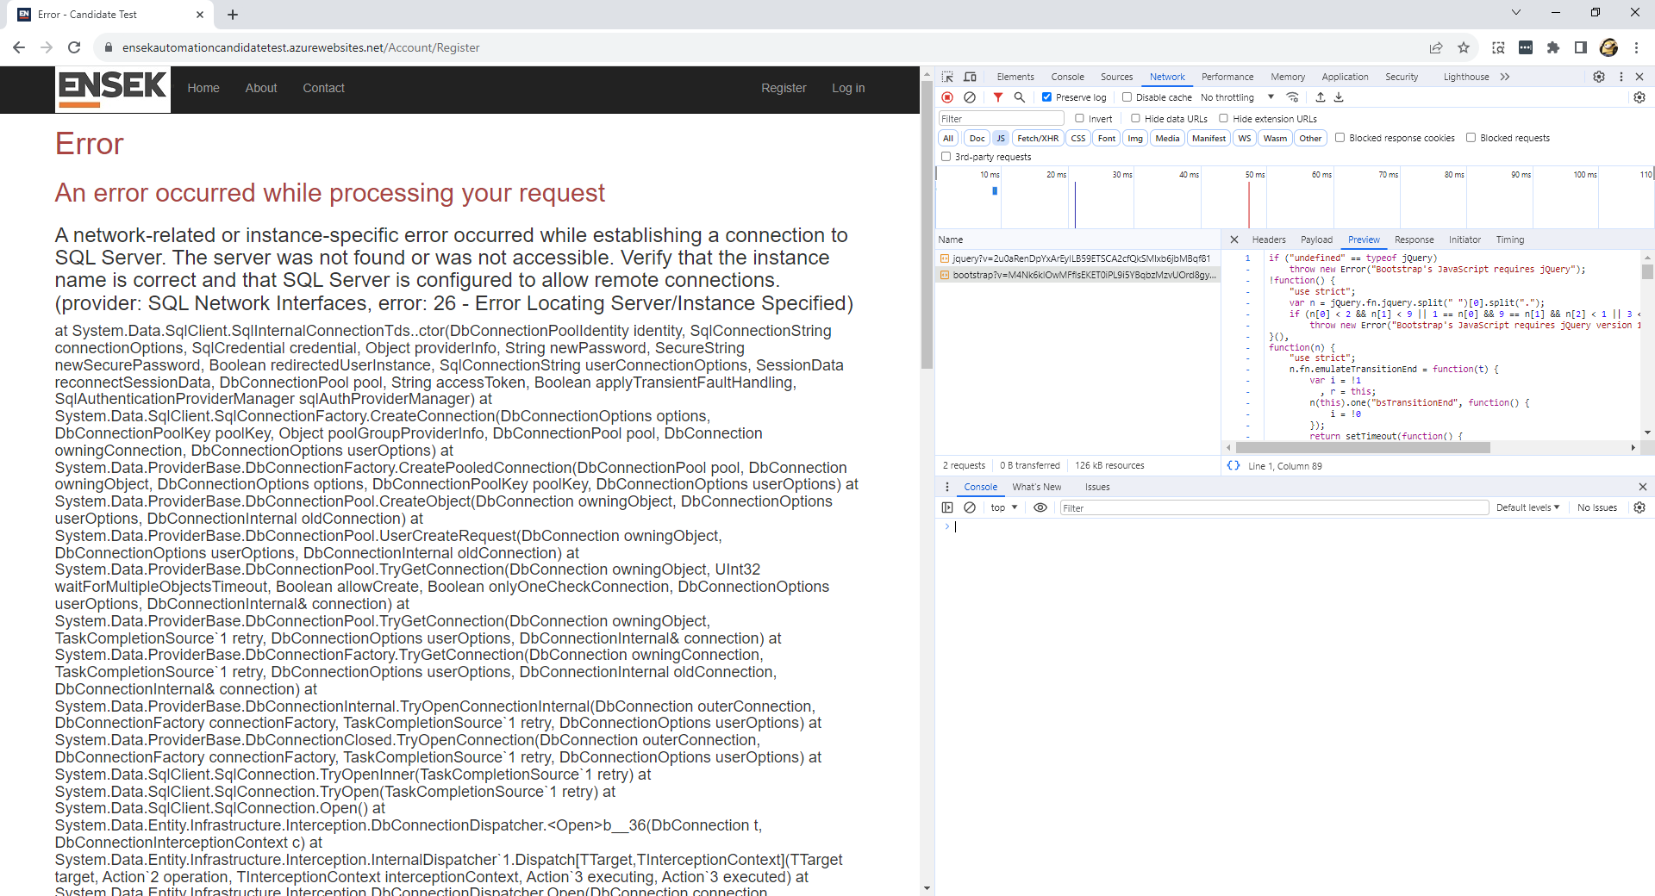

Error is thrown after around 20 seconds. Possible JQuery issue.